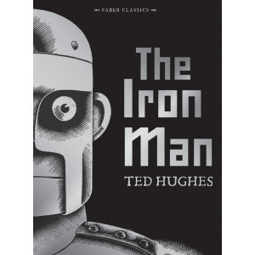

**Maths**

Each maths activity is attached underneath. There are two levels of difficulty for each one, A is easier and B is more difficult. You can choose which one you would like to attempt but try to challenge yourself.

**Monday:**

* Circles total, you must make sure each circle adds up to the same total. I.e. if there are two squares, they should add up to the total height of the two giants. You need to find the total height of the two giants first.

**Tuesday:**

* Finding differences- finding the difference means we need to subtract. You need to find the difference between each character and then put the differences in order.

**Wednesday:**

* Iron Factory –First you need to find the total number of Iron Men made each day to be able to answer the questions. If you finish the questions, you could think of some of your own questions you could ask.

**Thursday:**

* More than, less than – when using < and > remember the crocodile is always greedy so eats the larger amount. Look at the prices first and do comparisons. Then move on to the widths (how wide it is).

**Friday:**

* T T Rockstars – Choose a times table to practise on T T Rockstars or on Hit the Button. Time yourself for 3 minutes to see how many you can get right. Try three times and see if you can improve your score each time.

**English**

**Monday:**

Describe the scene with the Iron man starting with nouns, add adjectives, verbs and adverbs. Put these into sentences.

**Tuesday:**

Look at picture of the Iron Man Think of ideas for prepositions. Write sentences to describe the scene using prepositions.

**Wednesday:**

Look at the picture that includes speech bubbles next to the characters. Fill in the speech bubbles and write these as sentences using inverted commas.

**Thursday:**

Write a kenning to describe the Iron Man, remember it is like a riddle so don’t give it away! Two words per line.

**Friday:**

Write a diary entry as though you are the Iron Man.

**Reading**

**From the 20th of April I am going to be read a chapter a day of The Iron Man. Go on the Year 3 class page on the website to watch!**

Don’t forget to log into Bug Club. See how many books you can read in the next two weeks. I will be checking to see who has read the most.

**Science:**

Earlier in the year we learnt about light.

Go around your house and find metal objects.

Use a torch or a phone and shine a light on them.

Order the objects depending how bright they are. From the most reflective to the least.

Then make a list of things in your house that are light sources (this means that light comes from them).

**DT**

Create your own model of an Iron Man using recycled boxes/cardboard/bottles. Here are some examples…

**Art**

Use kitchen foil, paper and pencils to make a portrait of the iron man.

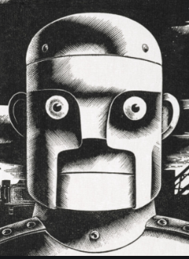

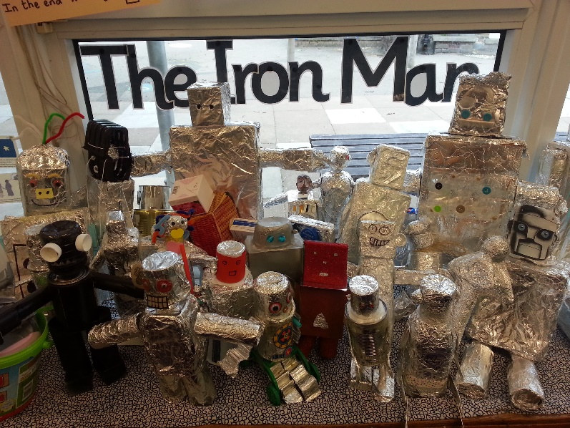

**PE**

Joe Wicks is doing live PE on Youtube every morning at 9am. You can find the workout at any time in the day though. Please make sure you have an adult’s permission to use Youtube.