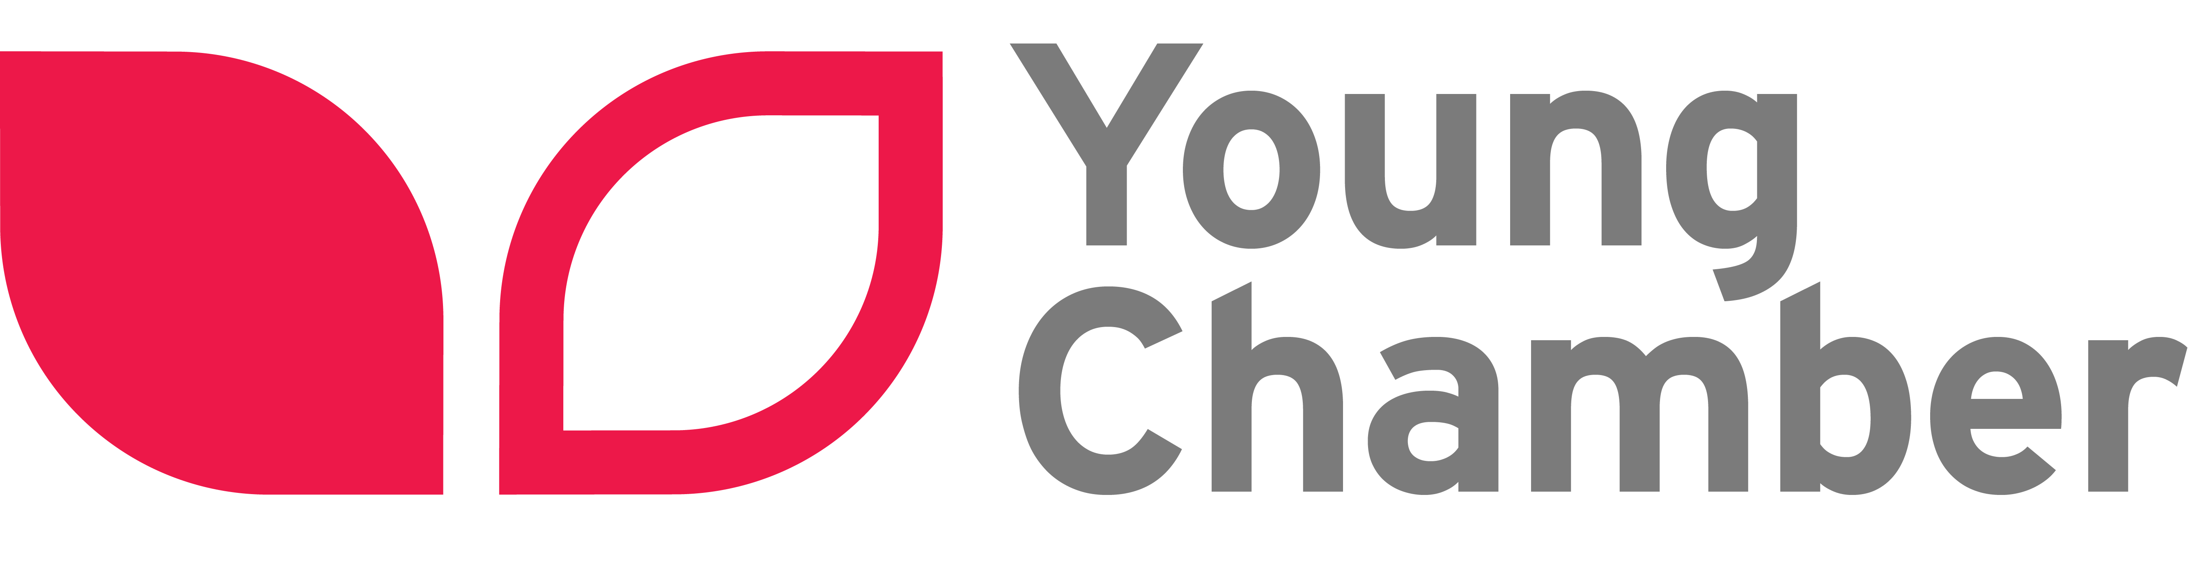

**Hobbies and Interests – what do I enjoy doing in my spare time (what skills do you need for this?):**

Some of my hobbies and interests include…

**Achievements (What have I accomplished that I am most proud of?):**

My best achievement to date was/is…

**Skills and Strengths (What am I good at?):**

I am…

**School and Education:**

Primary School:

Class:

Subjects I study include:

My **strongest** subject is: My **favourite** subject is:

**Personal Profile (A little bit about me – what sort of qualities do I have?):**

Picture

Name:

Primary School, Wirral

Year / Class: