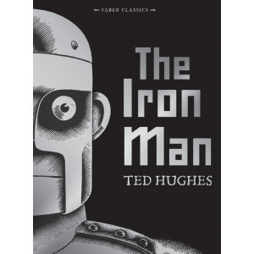

**English**

**Monday:**

For this sheet you need to know a verb is a doing word and a noun is something you can see. Also when you are asked to underline the main clause, remember this is a phrase that makes sense on its own.

**Tuesday:**

This is a continuation of yesterday but a little bit harder. Key information is that a main clause is a phrase that makes sense on its own.

**Wednesday:**

Conjunctions are used to link to sentences together. Work through the sheet answering questions about conjunctions.

**Thursday:**

Conjunctions but a little bit trickier. Use your knowledge from yesterday to help you with today’s sheet.

**Friday:**

Read the information about Dream Holidays and answer the questions on the next page.

**Maths**

**Monday:**

* Ordering numbers – look carefully at the number lines to see what the numbers are going up in. Remember ‘ascending’ means going from smallest to largest.

**Tuesday:**

* Ordering numbers 2 – use your knowledge of the word ‘ascending’ from yesterday. Today you are also using ‘descending’ which means biggest to smallest.

**Wednesday:**

* Adding and subtracting – on this sheet, each square is worth one hundred (like our hundred squares in class). Use this to help you work through the questions

**Thursday:**

* Adding and subtracting 2 – read through the questions carefully. On the second question you need to prove who was correct, make sure you explain how you know.

**Friday:**

* T T Rockstars – Choose a times table to practise on T T Rockstars or on Hit the Button. Time yourself for 3 minutes to see how many you can get right. Try three times and see if you can improve your score each time.

**Reading**

**From the 20th of April I am going to be read a chapter a day of The Iron Man. Go on the Year 3 class page on the website to watch!**

Don’t forget to log into Bug Club. See how many books you can read in the next two weeks. I will be checking to see who has read the most.

**Art**

Use Youtube to search for ‘How to draw the Iron Giant’ and use the tutorial to have a go at drawing your own Iron Man. Ask an adults permission before using Youtube.

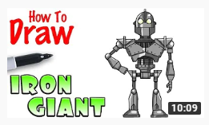

**Science:**

Draw an arrow on a piece of paper i.e. 🡪

Fill up a bottle of water with water and put the piece of paper on the opposite side of the bottle from where you are.

See if you can get the arrow to point the other way, try moving the piece of paper further away or side to side.

**PE**

Joe Wicks is doing live PE on Youtube every morning at 9am. You can find the workout at any time in the day though. Please make sure you have an adult’s permission to use Youtube.